**Penta 1**

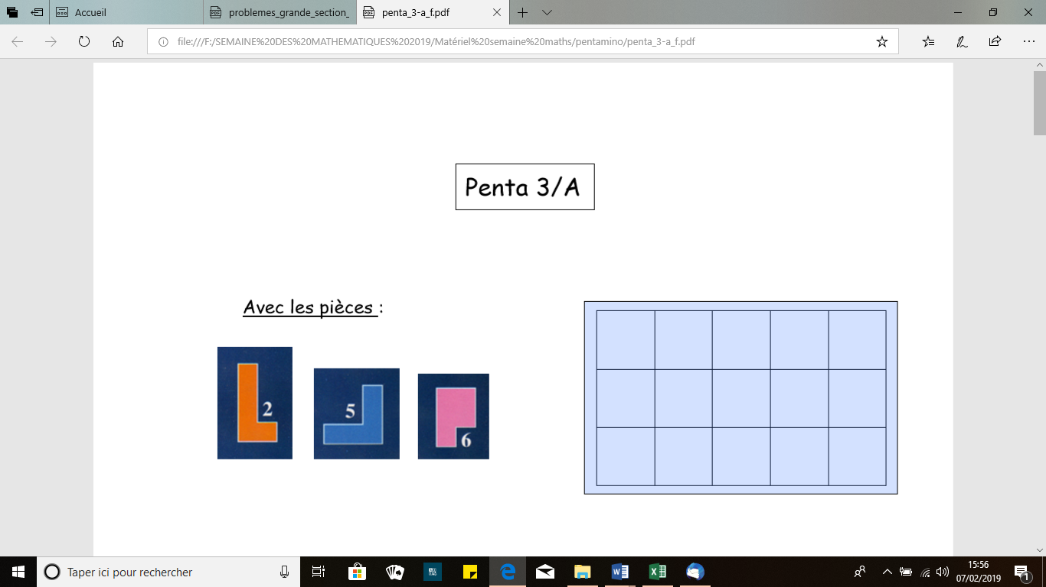

|  |  |  |  |  |
| --- | --- | --- | --- | --- |
|  |  |  |  |  |
|  |  |  |  |  |
|  |  |  |  |  |

**Penta 2**

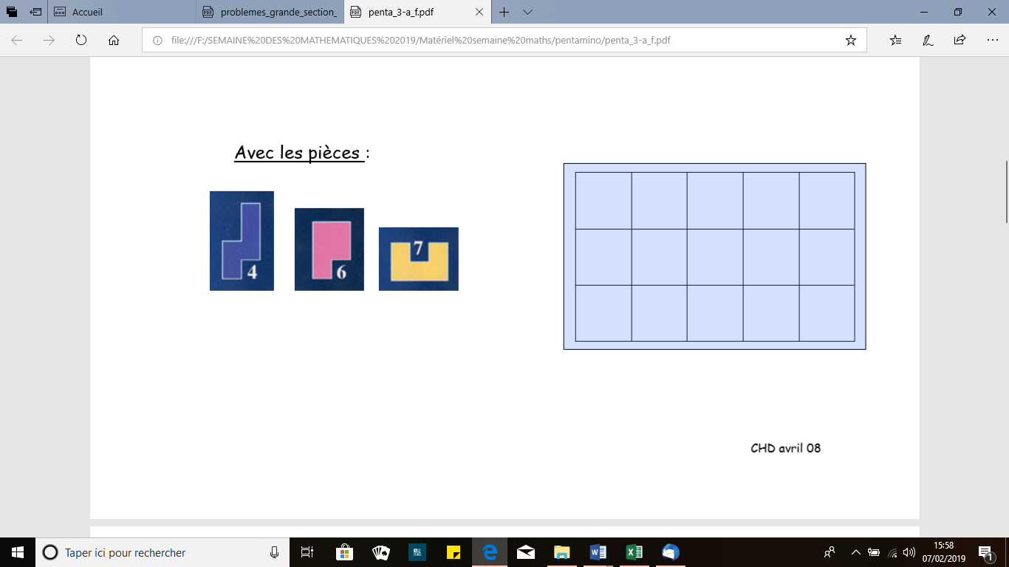

|  |  |  |  |  |
| --- | --- | --- | --- | --- |
|  |  |  |  |  |
|  |  |  |  |  |
|  |  |  |  |  |

**Penta 3**

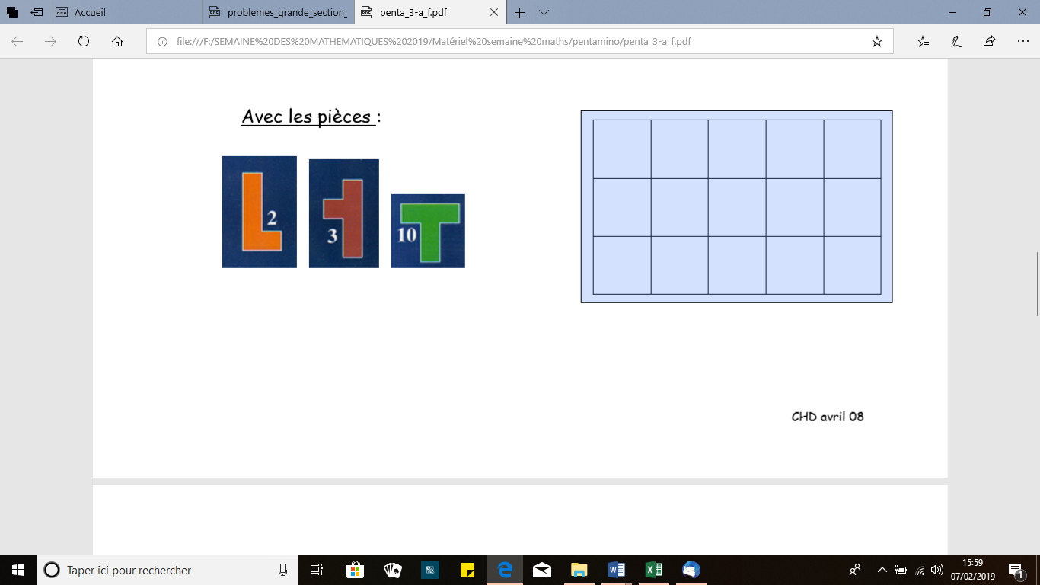

|  |  |  |  |  |
| --- | --- | --- | --- | --- |
|  |  |  |  |  |
|  |  |  |  |  |
|  |  |  |  |  |

**Penta 4**

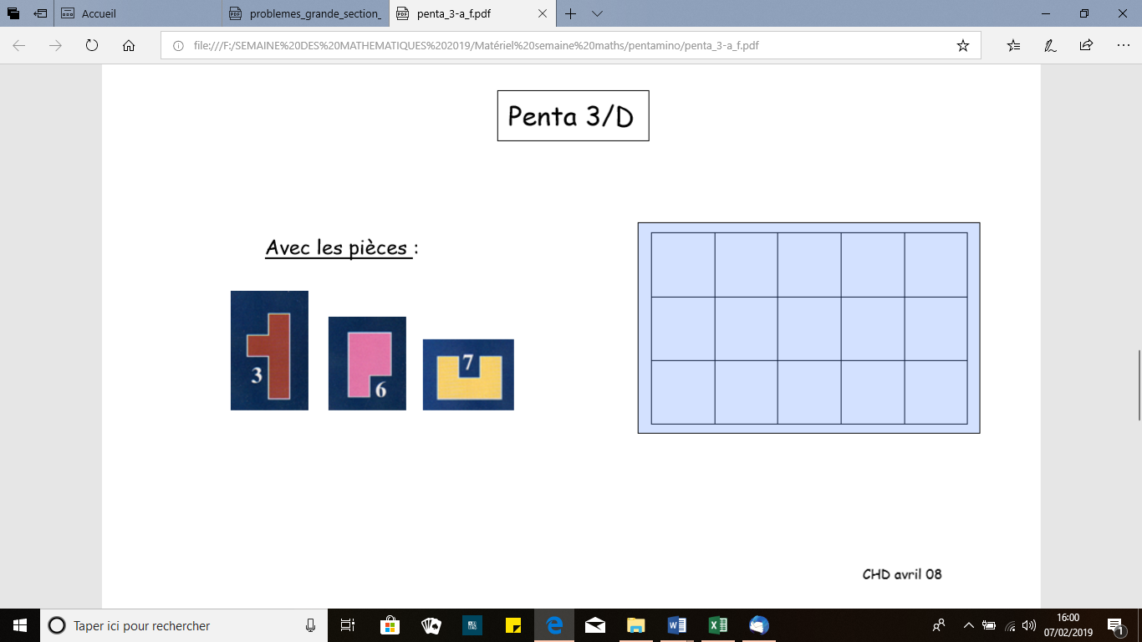

|  |  |  |  |  |
| --- | --- | --- | --- | --- |
|  |  |  |  |  |
|  |  |  |  |  |
|  |  |  |  |  |

**Penta 5**

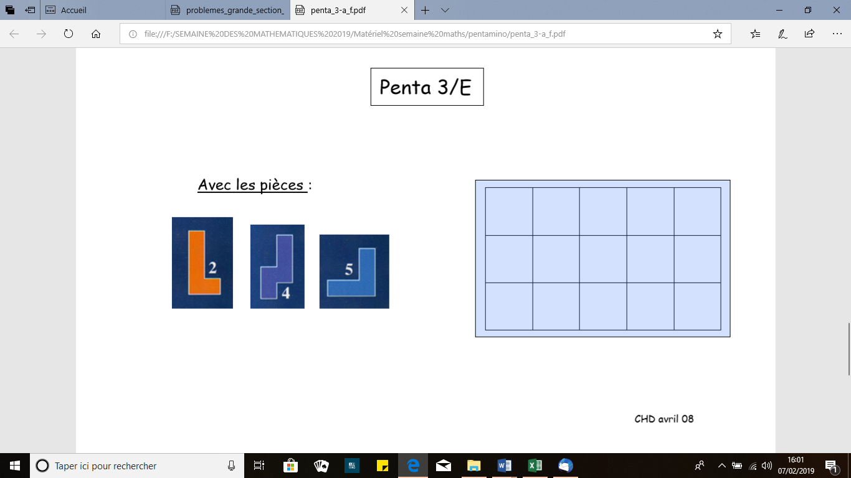

|  |  |  |  |  |
| --- | --- | --- | --- | --- |
|  |  |  |  |  |
|  |  |  |  |  |
|  |  |  |  |  |

**Penta 6**

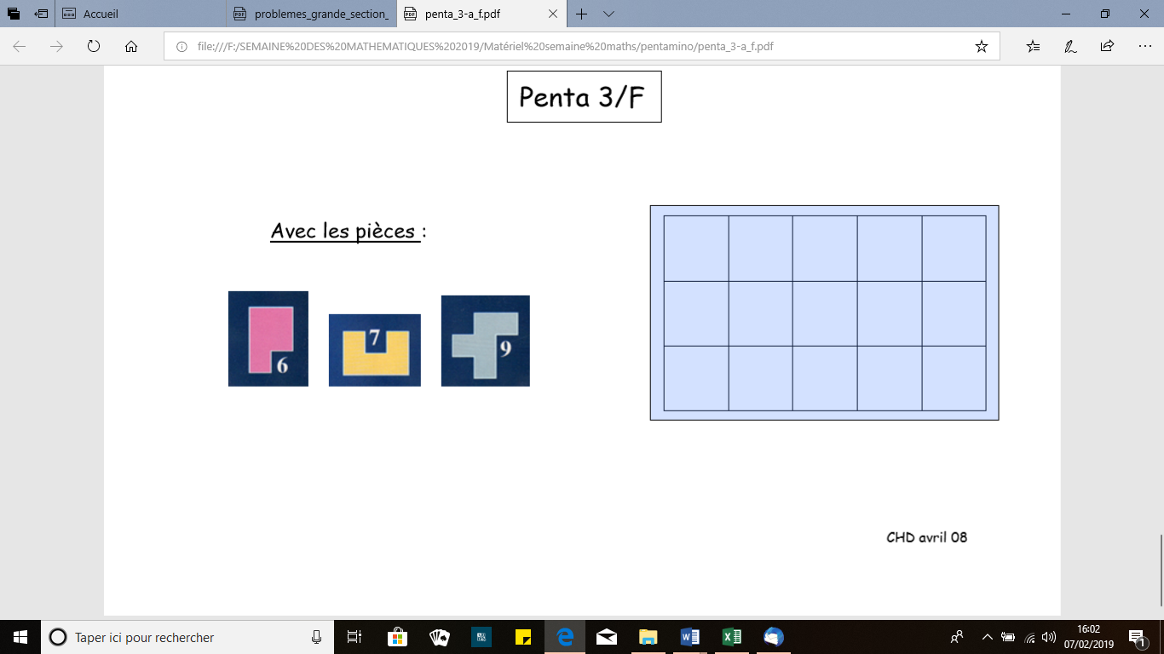

|  |  |  |  |  |
| --- | --- | --- | --- | --- |
|  |  |  |  |  |
|  |  |  |  |  |
|  |  |  |  |  |

**Penta 7**

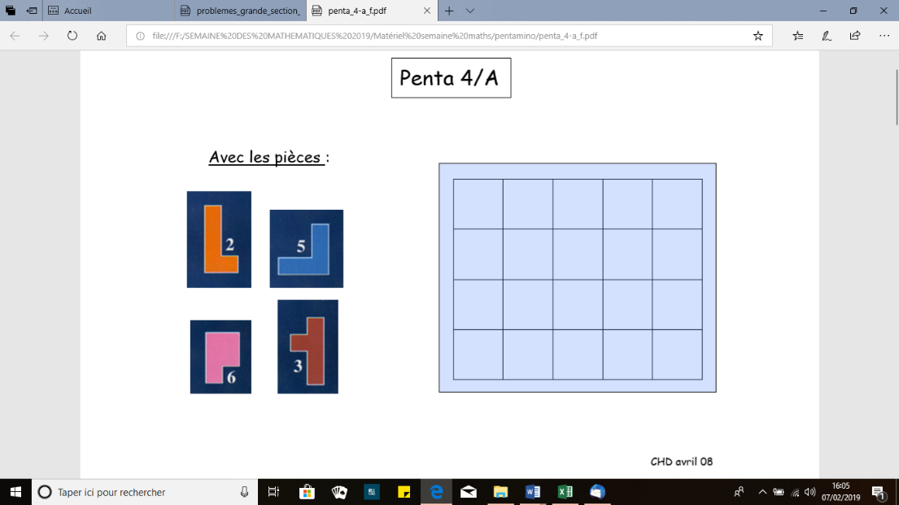

|  |  |  |  |  |
| --- | --- | --- | --- | --- |
|  |  |  |  |  |
|  |  |  |  |  |
|  |  |  |  |  |
|  |  |  |  |  |

**Penta 8**

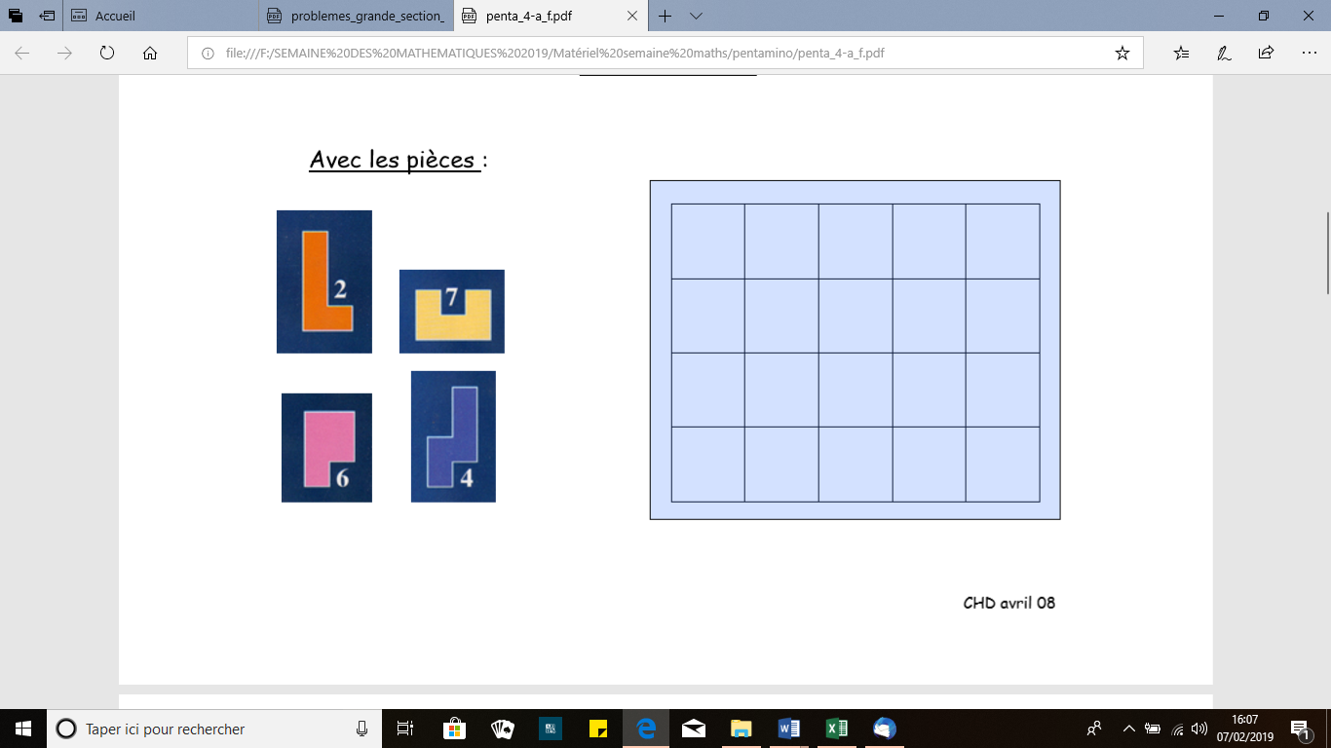

|  |  |  |  |  |
| --- | --- | --- | --- | --- |
|  |  |  |  |  |
|  |  |  |  |  |
|  |  |  |  |  |
|  |  |  |  |  |

**Penta 9**

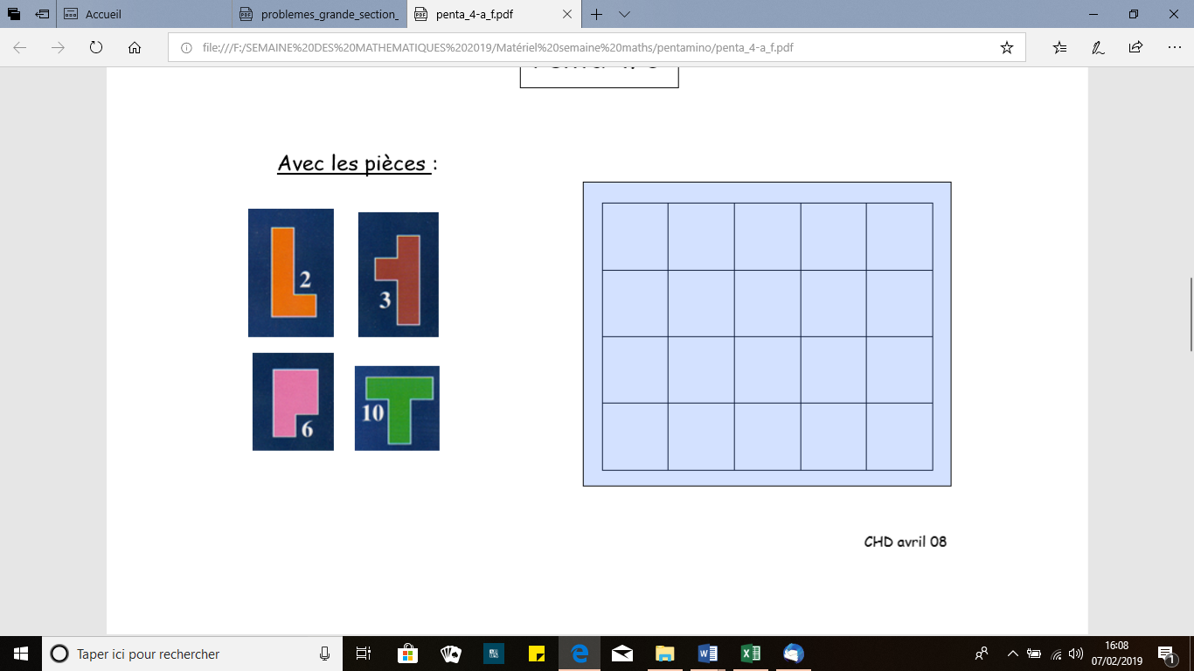

|  |  |  |  |  |
| --- | --- | --- | --- | --- |
|  |  |  |  |  |
|  |  |  |  |  |
|  |  |  |  |  |
|  |  |  |  |  |

**Penta 10**

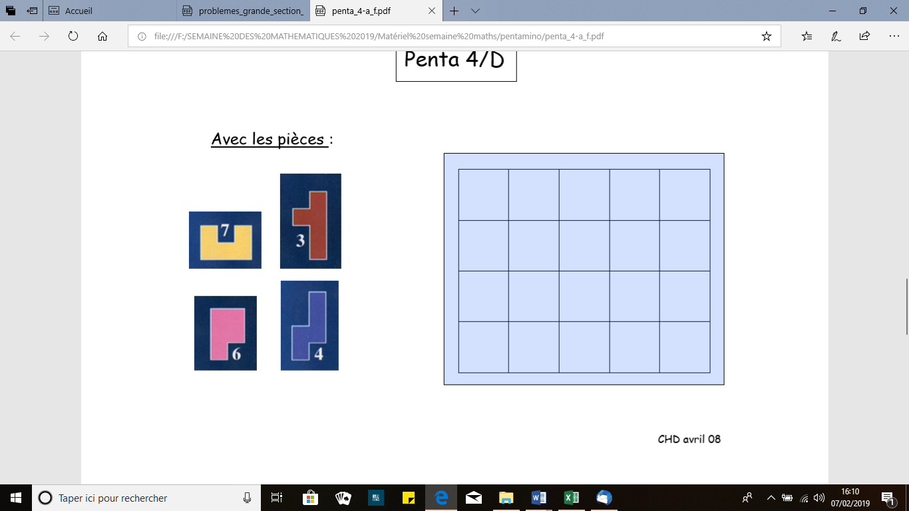

|  |  |  |  |  |
| --- | --- | --- | --- | --- |
|  |  |  |  |  |
|  |  |  |  |  |
|  |  |  |  |  |
|  |  |  |  |  |

**Penta 11**

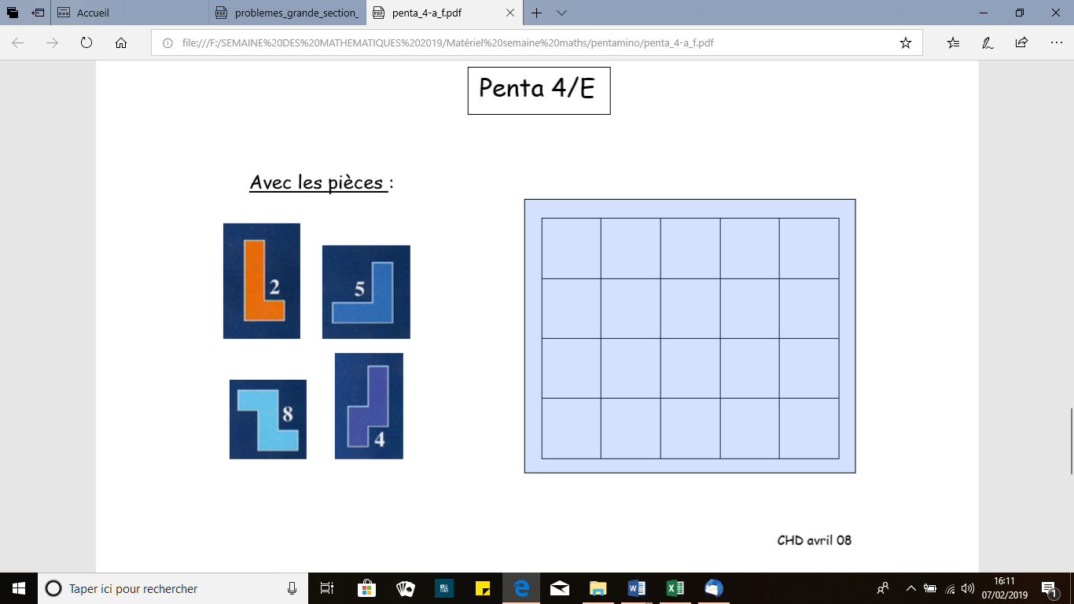

|  |  |  |  |  |
| --- | --- | --- | --- | --- |
|  |  |  |  |  |
|  |  |  |  |  |
|  |  |  |  |  |
|  |  |  |  |  |

**Penta 12**



          
          
          
          
          
          